Name: Muhammad Shahzaib
Roll No: FALL-23-BSCS-251
Section: G
Subject: Web Technologies LAB
Task: Timetable



Department of Computer Science

Lab 1: Setting up the Web Development Environment
– Objectives:
- Configure a developer environment (VS Code, browsers, Git) and understand the basic web stack.
- Tools/Tech:
- VS Code, Chrome/Firefox, Git/GitHub, Node.js (optional)
- Tasks/Steps:
- Install VS Code and essential extensions (Live Server, Prettier).
- Install Git and create a GitHub account/repository for the course.
- Clone a starter repo and run Live Server.
- Create a README with project structure and commit changes.
- Deliverables:
- GitHub repo with initial commit, README, and a simple index.html served via Live Server.
- Environment installed and verified (4), correct Git workflow & commit history (4), README quality (2). Solution:
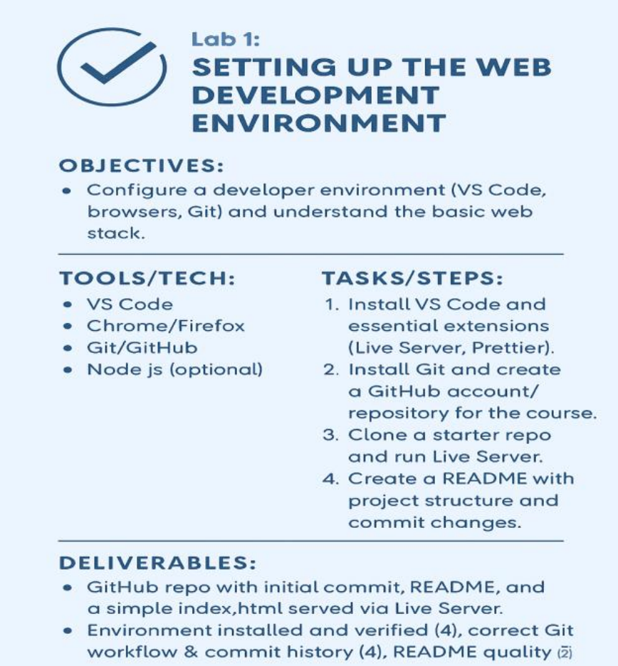

- Install a Code Editor
• Download and install Visual Studio Code
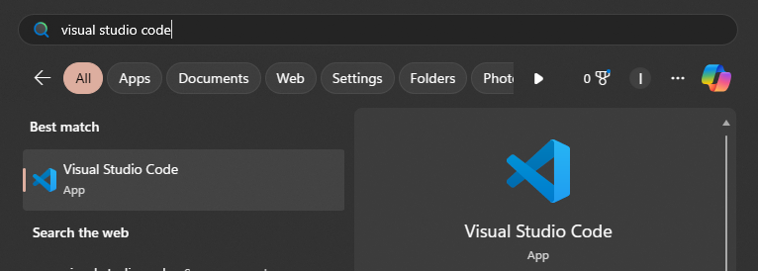
- Install Web Browsers
• Ensure you have the latest versions of Google Chrome and Mozilla Firefox for testing
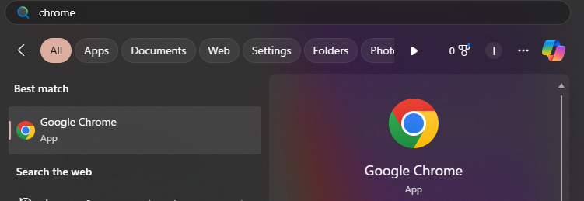
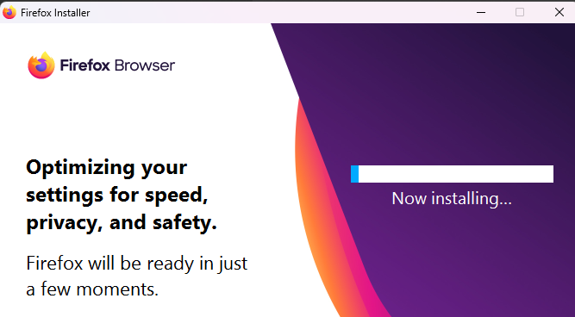

- Set Up Version Control
• Install Git
• Configure Git with your username and email:
• git config --global user.name "Your Name"
• git config --global user.email you@example.com
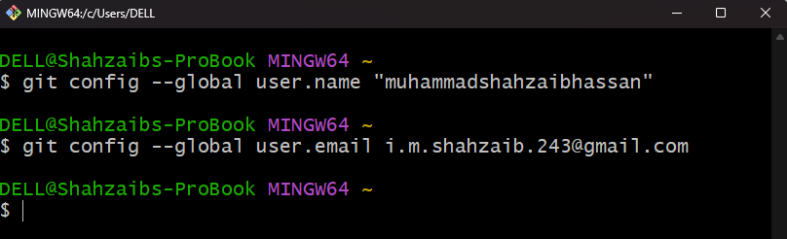
- Create a Project Folder
• Make a folder named WebDevLab1 on your desktop or preferred location
• Inside, create subfolders: html, css, js, and assets
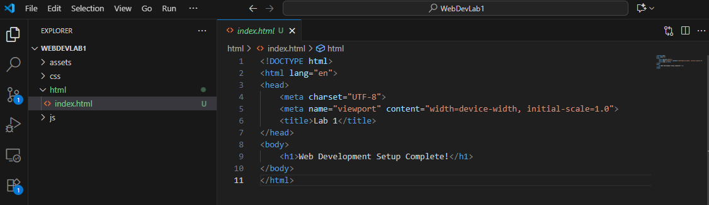
- Initialize Git Repository
• Open the folder in VS Code
• Run: git init
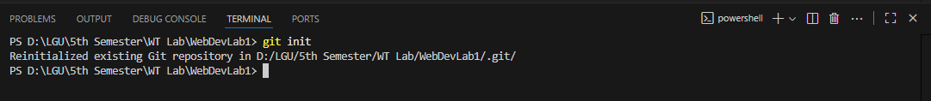
6.Install Live Server
• In VS Code, go to Extensions → Search for “Live Server” → Click Install
• Right-click your index.html file → “Open with Live Server”

7. Verify Setup
- Open index.html and add:
- <!DOCTYPE html>
<html>
<head><title>Lab 1</title></head>
<body><h1>Web Development Setup Complete!</h1></body>
</html>
- Launch with Live Server to confirm everything works
